Introduction to the Companies Participating in the 15th Beijing International Vacuum Exhibition

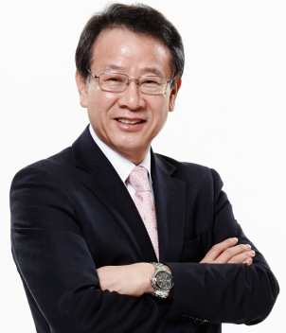
[1] ULVAC KOREA CO., LTD
www.ulvackorea.co.kr

□ PRESIDENT : Paik, Choong-Ryul

□ INTRODUCTION & MAIN PRODUCTS

ULVAC Korea has been supplying total solutions about vacuum since July of 1995, by using the know-how with abundant experiences of manufacturing equipment, analysis evaluation, measuring instrument, materials, services, softwares and so on.
Main manufacturing products are FPD & semi-conductor equipment, vacuum components.

□ MAIN COMPONENTS
• Leak Detector(HELIOT Series) • Process Gas Monitor(Qulee Series)
• Oil Rotary Pump(VD Series) • Dry Vacuum Pump(CR/Gr Series)
• High-Speed Spectroscopic Ellipsometer(UNECS Series)
• Crystal Oscillation type of Deposition Controller(CRTM Series)
• Vacuum Gauge(G-Tran Series)

NO | PARTICIPANTS | Company | TITLE | CONTACT |  | Remark
 |  |  |  | Mobile | e-mail
1 | Paik, Choong-Ryul | ULVAC KOREA CO., LTD | Chairman | 010-9013-2921 | choong-ryul_paik@ulvac.com
2 | Park, Sang-Sin | ULVAC KOREA CO., LTD  Sales Team | Senior  Manager | 010-4717-2921 | sang-sin_park@ulvac.com

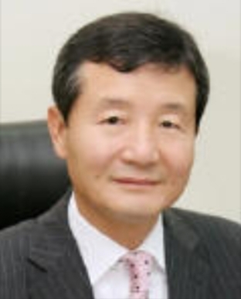
[2] KSM CO., LTD
www.ksm.co.kr

□ PRESIDENT : Kim, Yun-Ho

□ INTRODUCTION & MAIN PRODUCTS
Since founded in 1979, KSM has become one of world’s renowned sealing component manufacturer in the world. KSM’s core sealing expertise come from continuous improvement and R&D, which facilitates innovation in high tech industries such as semiconductor, display, solar panel, aerospace, and automotive industries.

□ MAIN PRODUCTS

• Welded Metal Bellows Heater • Mechanical Seal • Ferro-Seal
• Fine Ceramics

NO | PARTICIPANTS | Company | TITLE | CONTACT |  | Remark
 |  |  |  | Mobile | e-mail
1 | Kim, Yun-Ho | KSM CO., LTD | Chairman | 010-3798-7100 | yhkim@ksm.co.kr
2 | Lee, Seung-Hwan | KSM.CO., LTD  Sales Team | Senior  Manager | 010-4902-9319 | shwanlee@ksm.co.kr

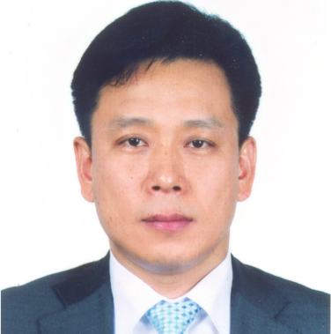
[3] INFOVION Inc.
www.infovion.com

□ PRESIDENT : Kim, Yong-Hwan

□ INTRODUCTION & MAIN PRODUCTS

1. Target/Current Business
• IGZO In-Line Sputter
• Ⅲ-Ⅴ Epitaxial Semiconductor Wafer
• Color Glass for Intelligent Building
• Flexible Touch using Ag-NanoWire

2. Product Items
• OLED Cluster System • Sputtering Cluster System
• CIGS Solar Cell Cluster System • E-Beam Evaporator
• PECVD, MOCVD, CVD for Graphene • EBA(Energy, Beam Annealing)
• Ion Beam System (IBD, IBAD for optic coating, Ion Milling)
• Source(RF/DC Source, Linear Ion/Electron Source, Anode Ion Source)

No | PARTICIPANT | COMPANY | TITLE | CONTACT |  | REMARK
 |  |  |  | Mobile | e-mail
1 | Kim, Yong-Hwan | INFOVION Inc. | President | 010-3433-2019 | infovion@daum.net

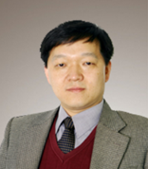
[4] PSTEK CO., LTD
www.pstek.co.kr

□ PRESIDENT : Seong, Hwan-Ho

□ INTRODUCTION & MAIN PRODUCTS

Since its establishment in 1998, PSTEK has been supplying industrial power system with the best quality in the short delivery time and providing from designing, manufacturing, installation to post management. Our main business fields are induction heating inverter and converter.

Main products are dual frequency heat treatment system in inverter and in converter UV lamp ballast, BWMS rectifier, plasma power supply, optical sintering system, electrostatic chuck system, power supply for dust collector.

In addition, consulting services that provide design, development and manufacturing tailored to the specifications of customers are also our differentiated capabilities.

Our main strength is R&D power and high quality, so we have maintained our research personnel with more than 30% of the total employees since our establishment.

No | PARTICIPANT | Company | TITLE | CONTACT |  | REMARK
 |  |  |  | Mobile | e-mail
1 | Seong, Hwan-Ho | PSTEK CO., LTD | President | 010-2395-4808 | hhsung@pstek.co.kr

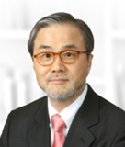
[5] UCT KOREA CO., LTD
www.uctkorea.co.kr

□ PRESIDENT : Ahn, Bung-Hyeok

□ INTRODUCTION & Main PRODUCTS

Since founded in 1997, UCT Korea has been specialized in valves and fittings for manufacturing system of semi-conductor and LCD such as gas supplying devices, various types of valves and fittings necessary for the whole manufacturing process of semi-conductor and LCD on the basis of the know-how of 30-year experiences in the industry.

UCT Korea is the exclusive distributor of KITZ in Korea, which is the Japanese worldwide manufacturer of piping devices for semi-conductor & LCD producing facilities with leading technology in metal processing and welding in Japan.

UCT Korea is also the holding company of Q-lok, the manufacturer of various parts for piping installation system.

And UCT Korea offers technical education and training for piping system in semi-conductor and LCD manufacturing factories.

Main products are Gas & Chemical Delivery System, Diaphragm & Bellows, Valvs, VCR & Welded Fittings, Q-Lok Compression Fittings, Q-Lok Valves, Tubes & Fittings/ASME BPEs and etc.

No | PARTICIPANTS | COMPANY | TITLE | CONTACT |  | REMARK
 |  |  |  | Mobile | e-mail
1 | Ahn, Bunghyeok | UCT Korea | PRESIDENT | 010-5315-1088 | bhahn@uctkorea.co.kr
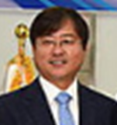
[6] CN1 CO., LTD
www.CN-1.co.kr

□ PRESIDENT : Jeong, Jaehack

□ INTRODUCTION & MAIN PRODUCTS
Since founded in November 2008, CN1 has offered a total solution of a
traveling wave/showerhead type of ALD by using atomic layer deposition core technology.

1. Main products are as follows:
- Thermal ALD Process (Plasma Process Available)
- Gap Adjustable between Showerhead and Substrate
- Variable gas delivery system : Bubbler, LDS etc.
- Available laminated & mixed process
- Max temperature : up to 500°C
- Substrate size : 4 ~ 12” Standard (wafer)

2. Product Items:
- Showerhead Type ALD Process
- Traveling Wave Type ALD Process
- Nano-Powder Coating ALD Process
- Furnace Type Batch ALD Process

Applications are Dielectric thin films : Al2O3, HfO2, ZrO2, TiO2, ZnO2, STO, ZnS, Laminate films, etc.

No | PARTICIPANT | COMPNAY | TITLE | CONTACT |  | REMARK
 |  |  |  | Mobile | e-mail
1 | Jeong, JaeHack | CN1 | PRESIDENT | 010-9907-5574 | jhjeong@cn-1.co.kr
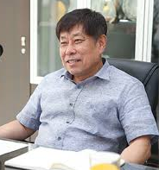
[7] DASAN ENGLNEERING CO., LTD
www.dasaneng.net

□ PRESIDENT : Kim, Do-Youl

□ INTRODUCTION & MAIN PRODUCTS

Since founded in February 1995, DASAN ENGINEERING has manufactured a various types of semi-conductor equipment and its parts, and vacuum valves on the basis of reliability of customer and impressive management.

Main products are various types of Gate Valve in standard DGV, Bellows Discrete series, and DGV Top link series.

□ MAIN PRODUCTS
- Gate Valve (standard DGV, Bellows Discrete & DGV Top link series)
- DAV Protection Angle Valve series
- Anti-Powder for Scrapper

No | PARTICIPANT | COMPANY | TITLE | CONTACT |  | Remark
 |  |  |  | Mobile | e-mail
1 | Kim, Do-YouL | DASAN ENG CO., LTD | PRESIDENT | 010-3307-3936 | dy10@dreamwiz.com
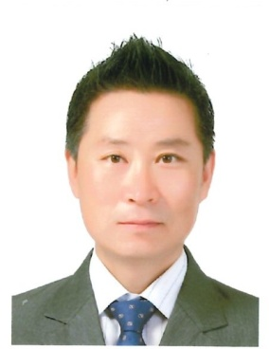
[8] MOLYTECH CO., LTD
www.molytech.co.kr

□ PRESIDENT : Lee, JaeSok

□ INTRODUCTION & MAIN PRODUCTS
MOLYTECH has been supplying a wide range of high performance lubrications to the electronic industry, manufacturing industry and automotive industry, with special lubrication, Food Grade, Contact, High/Low Temperature Grease and Heat transfer oil as well as Vacuum Pump Oil.

□ MAIN PRODUCTS
- Vacuum Pump oil
- Heat Transfer Fluid
- Specialty Lubricants etc

No | PARTICIPANT | Company | Title | Contact Pont |  | Remark
 |  |  |  | Mobile | e-mail Address
1 | Lee, JaeSok | MOLYTECH CO., LTD | President | 010-3838-3672 | sales@molytech.co.kr

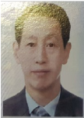
[9] EMC CO., LTD
www.shemc.co.kr

□ PRESIDENT : Kim, Hong-Beom

□ INTRODUCTION & MAIN PRODUCTS

EMC has specialized in fine machining and manufacturing for the medium-large sized machinery products in the field of Engine block for vessel, Nuclear Power Plant, ITER Project, Pump, Evaporation Facilities for Display since 1995.
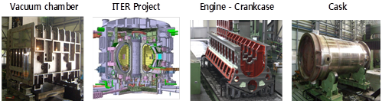

EMC are leading the precision processing industry with the best quality and innovation-challenging spirit, and obtained the ISO 9001, ISO 14001 and KEPIC for Nuclear power plant’s equipment. We are pioneering only one way by craftsmanship, and all staff are doing with every efforts to realize customer satisfaction by investment on R&D and advanced manufacturing facilities.

No | PARTICIPANTS | Company | Title | Contact Points |  | Remark
 |  |  |  | Mobile | e-mail Address
1 | Kim, Hongbeom | EMC | CEO | 010-6526-9501 | Khb3649@hanmail.net
2 | Cho, Raejin | EMC | COO | 010-8520-1864 | master21@shemc.co.kr
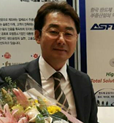
[10] AEROSPACE & SEMICONDUCTOR
FLOW CO., LTD
www.asflow.com

□ PRESIDENT : Kang, Du Hong

□ INTRODUCTION & MAIN PRODUCTS

ASFLOW Co., Ltd is a company specialized in the production of semiconductor equipment and high purity valves used for high purity gas lines. ASFLOW is the leading material & components group in Korea which contributes to the industry.

ASFLOW, first founded in May, 2000 has succeeded the domestic production of high purity valves that were once available only through importation. With the provision of valves, ASFLOW will expand not only in the domestic market, but also to China, Japan and Europe to affirm our brand image and further development as the worldwide leading company.

□ MAIN PRODUCTS
- Clean Fitting - Tube & Pipe - Diffuser & Filter
- Gas Regulator & Diaphragm Valve

No | PARTICIPANT | Company | Title | Contact Point |  | Remark
 |  |  |  | Mobile | e-mail Address
1 | Kim, Hyose | ASFLOW  Co., ltd | General Sales Manger | 010-8769-2920 | hskim@asflow.com

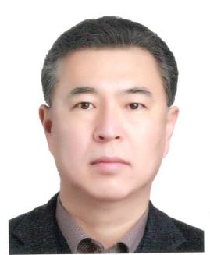
[11] RFPT CO., LTD
www.rfpowertech.co.kr

□ PRESIDENT : Lee, Dong-Heon

□ INTRODUCTION & MAIN PRODUCTS

RFPT (RF Power Tech Co.,Ltd) has an ability to design and manufacture high technology RF power and Matching Network for semiconductor, industrial plasma application and bio & medical plasma equipment as well for 10 years.

RFPT power solutions are being adapted with the plasma process such as PECVD, etching, ashing, surface cleaning and even atmospheric plasma applications.

Advanced RF technology enables to design a better plasma process with new developing products.

The goal of RFPT is to provide total RF solutions to customer and take a development with anyone who needs the RF solutions.

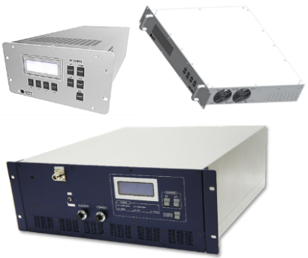
The products are RF Generator, RF matching Network, RF Accessories, and RF Drive AMP.
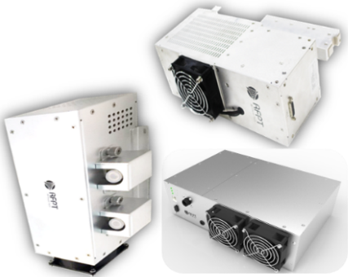
No | PARTICIPANTS | COMPANY | TITLE | CONTACT |  | Remark
 |  |  |  | MOBILE | e-mail
1 | Lee, Dong Heon | RFPT CO., LTD | CEO | 010-9002-3093 | dhlee@rfpowertech.co.kr
2 | Lee, Dae-Joon | RFPT CO., LTD | Director | 010-9348-0780 | David.lee@ rfpowertech.co.kr
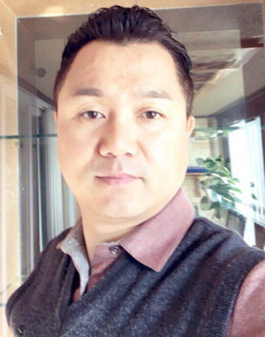
[12] SMB CORP.
www.smb.co.kr

□ PRESIDENT : Lee, Kyu-Ok

□ INTRODUCTION & MAIN PRODUCTS

Since its establishment in August 2000, it has been producing and selling special metal related raw materials and processed products.

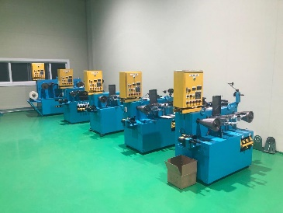
The main products are vacuum parts and semiconductor parts, tungsten and molybdenum, nickel wire and mesh.
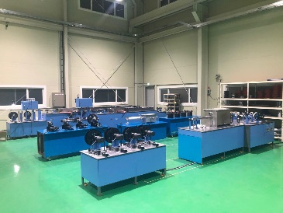
In particular, we are making every effort to improve our competitiveness through localization of the Korean semiconductor parts field. We are also doing our best to expand our supply capabilities of the parts in response to the recent increase in MLCC demand, as well as to expand into overseas markets such as China, Japan and Taiwan

No | PARTICIPANT | COMPANY | TITLE | CONTACT |  | Remark
 |  |  |  | MOBILE | e-mail
1 | PARK, Hyon | SMB | DIRECTOR | 010-4545-9315 | hpark@smbcorp.co.kr

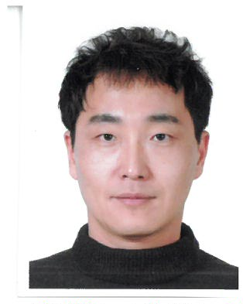
[13] MARUI KOREA CO., LTD
www.maruikorea.co.kr

□ PRESIDENT : Ko, Sang-Sik

□ INTRODUCTION & MAIN PRODUCTS

In October 2002, Awesome Lead INC. and Japan's Marui galvanizing co., Ltd which is the one of best surface treatment company has begun joint ventures of Marui Korea INC. through technical agreement.
Marui Korea has Super-sized facilities of surface treatment and manage laboratory to pursue developing high technology for satisfaction of various customer’s needs.

Recently OLED manufacturing M/C is coming into High demand on the market. To meet the market trend, Awesome Lead INC. established state of the art factory in 2017 that Awesome Lead Asan Factory pursues more cleanness, safe environment and high productivity.

Main business is provision of superior surface treatment technologies for IT, Display, Solar, Nuclear power, fine chemistry and so on by way of the Electrolytic polishing, Electrolytic cleaning, Precision cleaning, Bead blast, Passivation, Chemical polishing and so on.

No | PARTICIPANT | COMPANY | TITLE | CONTACT |  | Remark
 |  |  |  | MOBILE | e-mail
1 | Ko, Sang-Sik | MARUI KOREA | PRESIDENT | 010-4597-1706 | Koss.ep@awesomelead.com
[14] MKP CO., LTD
www.mkpsemi.com

□ PRESIDENT : Jun, Suk-Hwan

□ INTRODUCTION & MAIN PRODUCTS

Since founded in March 2016, MKP Co., Ltd has become Korea’s first and only company that succeeded in developing and manufacturing MFC(Mass Flow Controller), which is the core part in the process of manufacturing the semi-conductor.
This has brought the renovation in the semi-conductor market by replacing the importation only through the overseas advanced countries.
Our current major customers are Samsung Electrics and SK Hynix and triggering to open a new market.
Our main products are pressure sensors based on MFC as a MARU 9000 series, Pressure Insensitive MFC as MARU 7000 series, Normal MFC as MARU 5000 series and Display process MFC as MARU 3000 series.

No | PARTICIPANT | COMPANY | TITLE | CONTACT |  | Remark
 |  |  |  | MOBILE | e-mail
1 | Yang,  Dal Seung | MKP. | Vicw President | 010-9543-6778 | dsyang@mkpsemi.  com
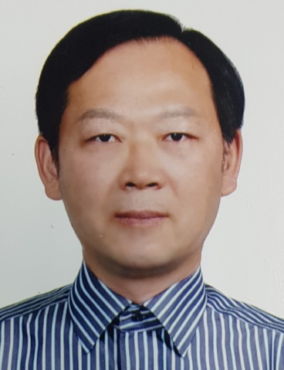
[15] WONCHANG VACUUM CO., LTD
www.wonvac.com

□ PRESIDENT : Kim, Jeahoung

□ INTRODUCTION & MAIN PRODUCTS

WonChang Vacuum Company (WONVAC) has been producing and supplying various types of Vacuum Pumps to meet industrial vacuum in Korea as well as in the world through distribution networks since its establishment in 1982.

□ MAIN PRODUCTS
- Dry Carbon Vane Pumps
- Oil Rotary Vane pumps
- Dry Type Claw Vacuum and Pressure pumps
- Mechanical Boosters
- Vacuum System

No | PARTICIPANTS | COMPANY | TITLE | CONTACT |  | Remark
 |  |  |  | MOBILE | e-mail
1 | Kim, Jeahoung | WONVAC | CEO | 010-5246-7541 | jaehkim@wonvac.  com
2 | Roh, Heejong | WONVAC | V.P. | 010-4205-9570 | hjroh@wonvac.  com

